**Software Management Lab**

## Accessing the AWS Management Console

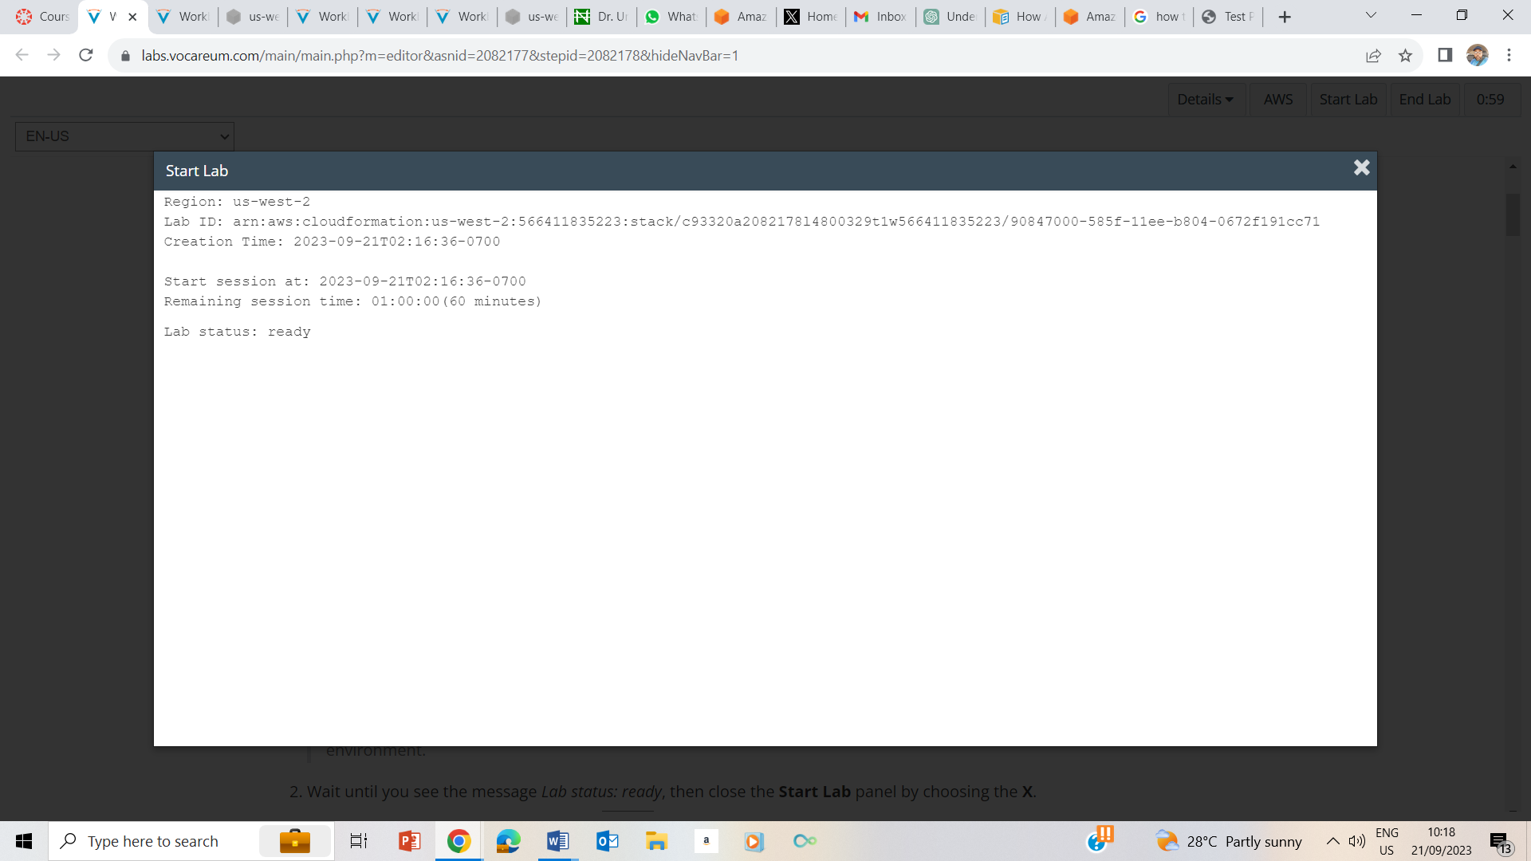

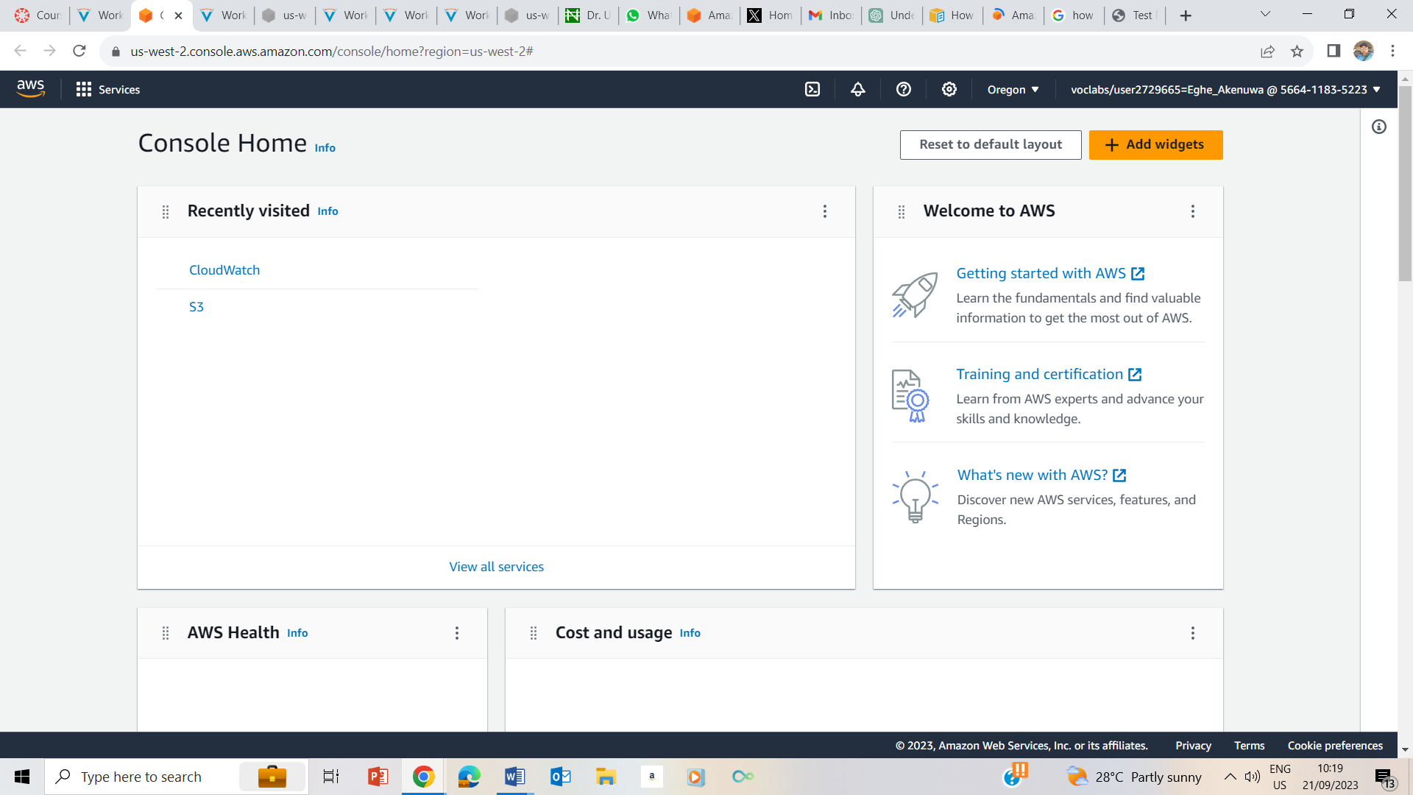

## Task 1: Use SSH to connect to an Amazon Linux EC2 instance

### Windows Users: Using SSH to Connect

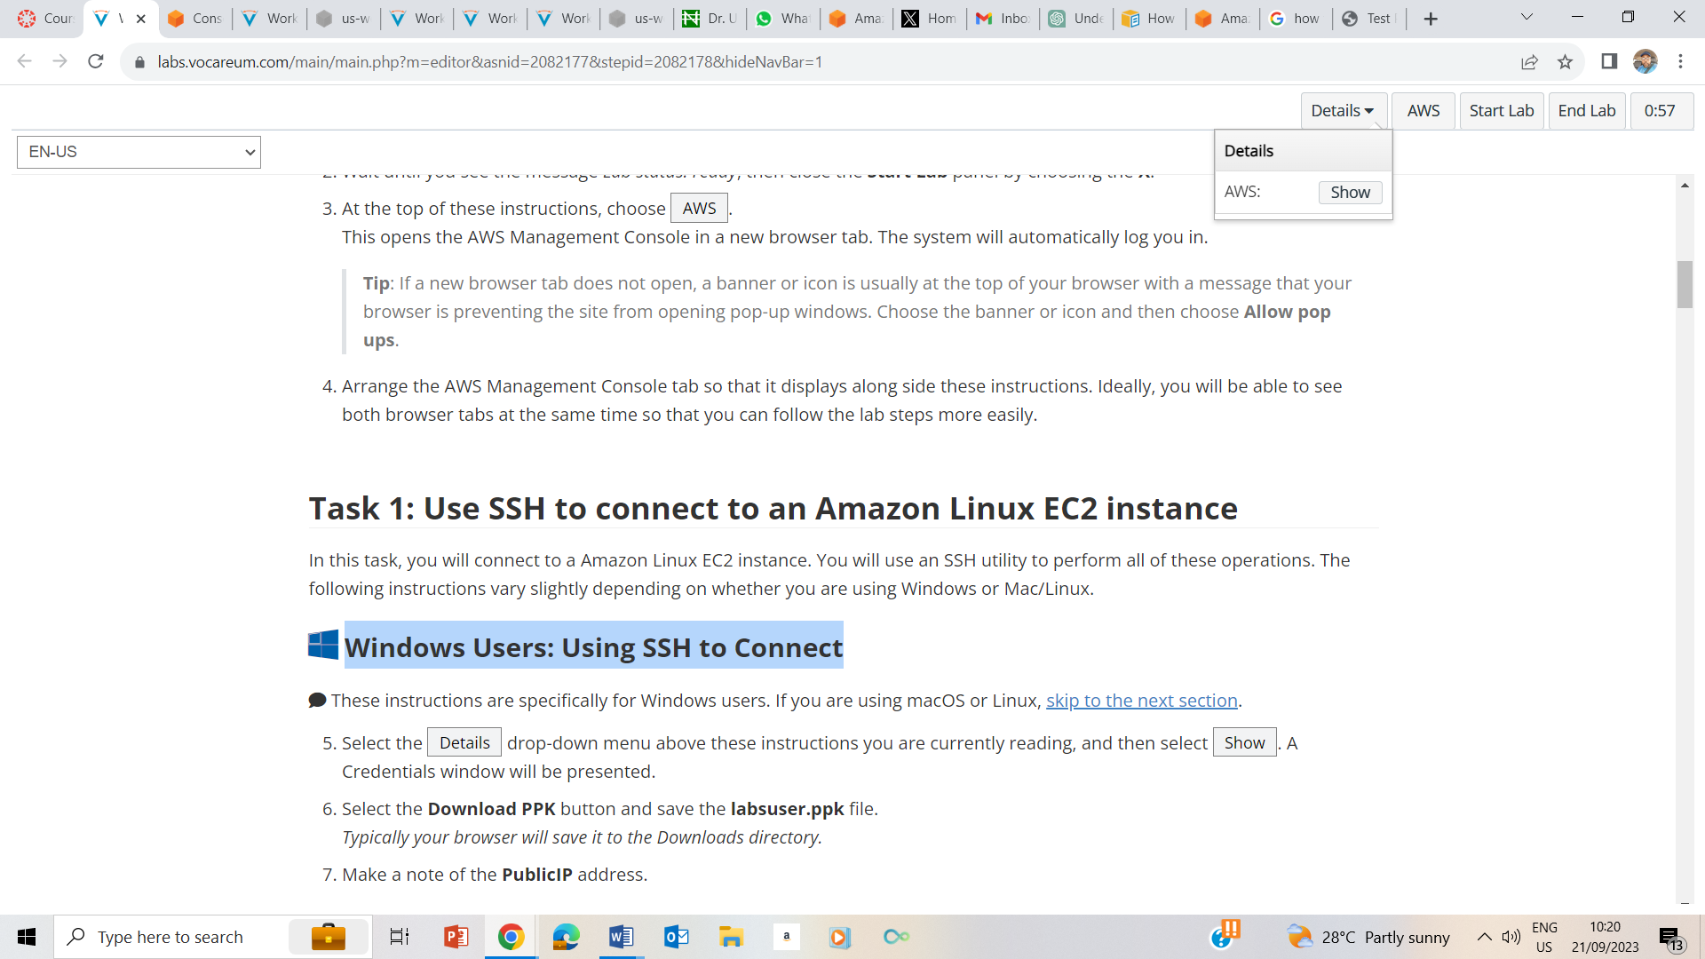

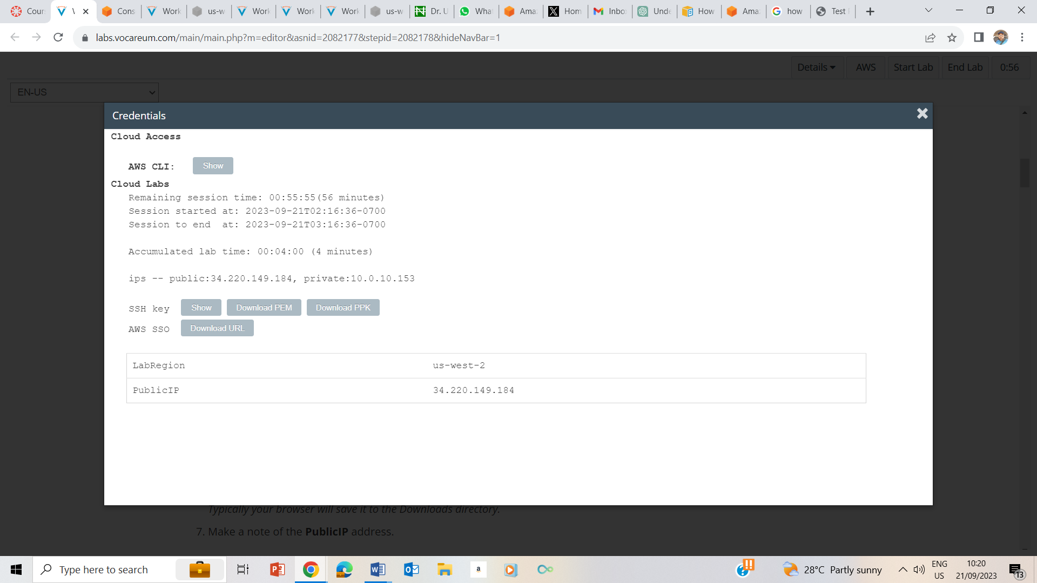

5-8. Clicked on the AWS and also clicked on Show ; downloaded PPK file, and noted the Public ip address as 34.220.149.124.

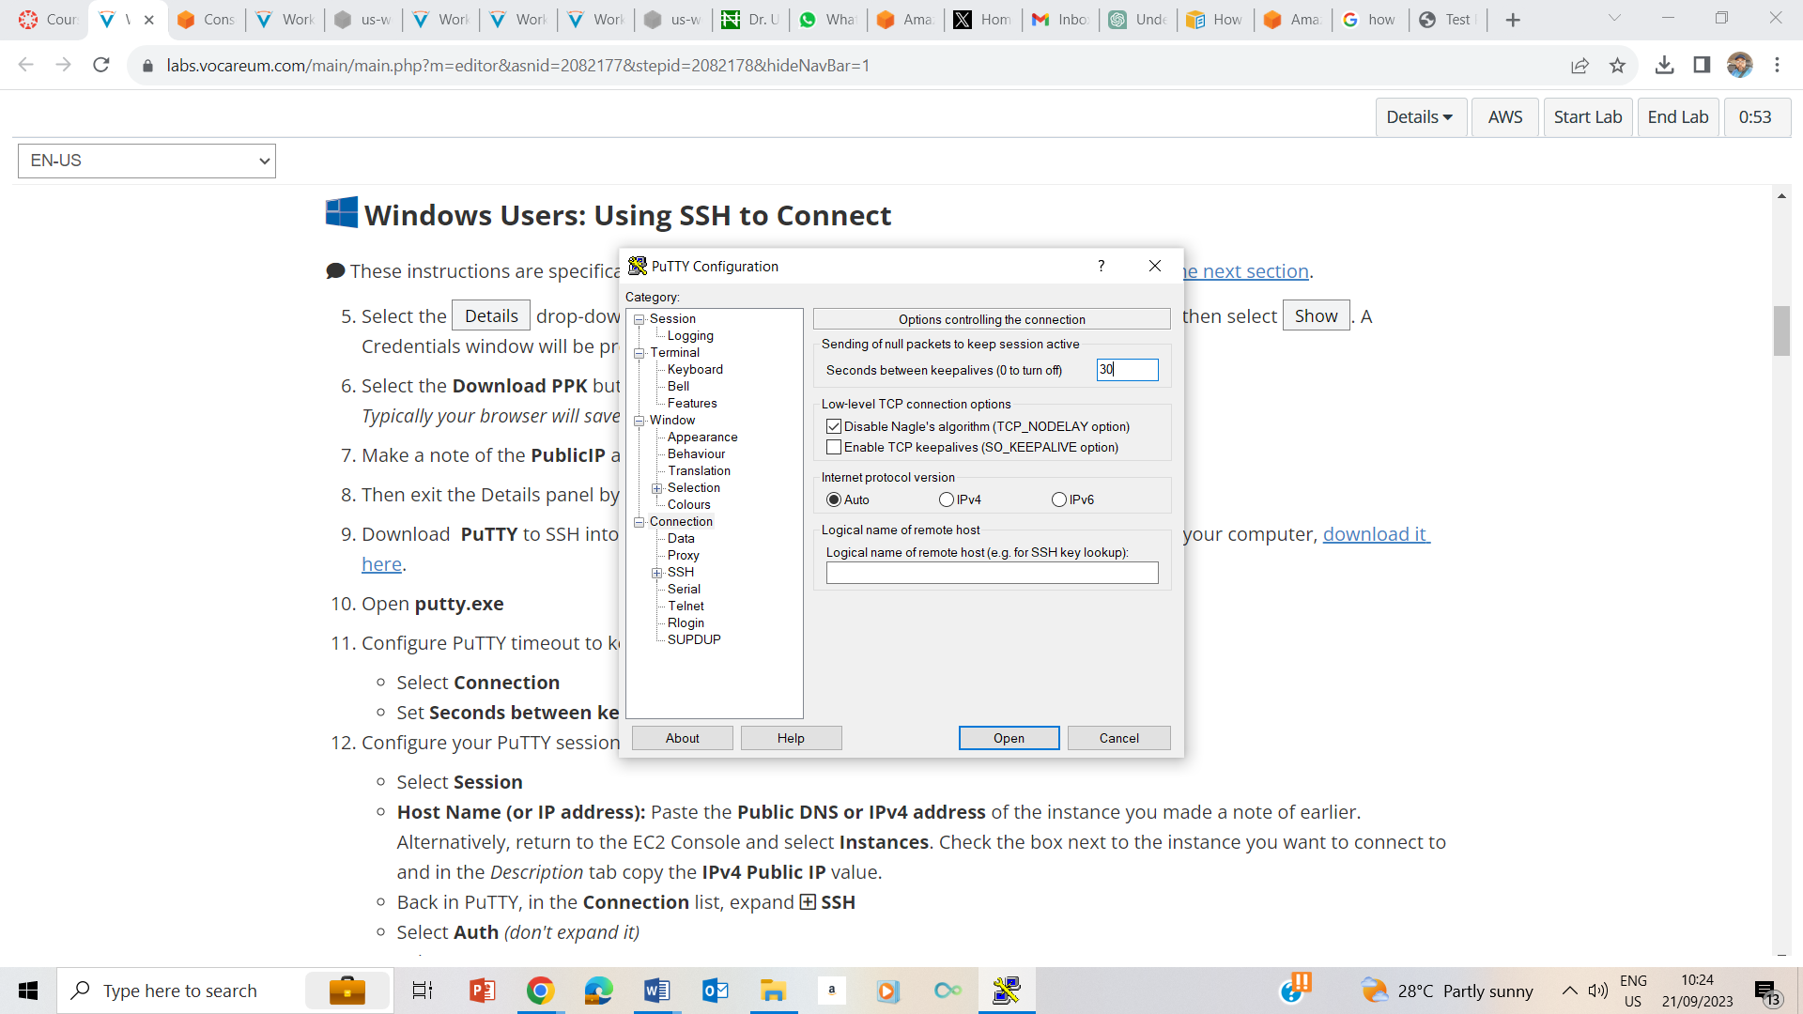

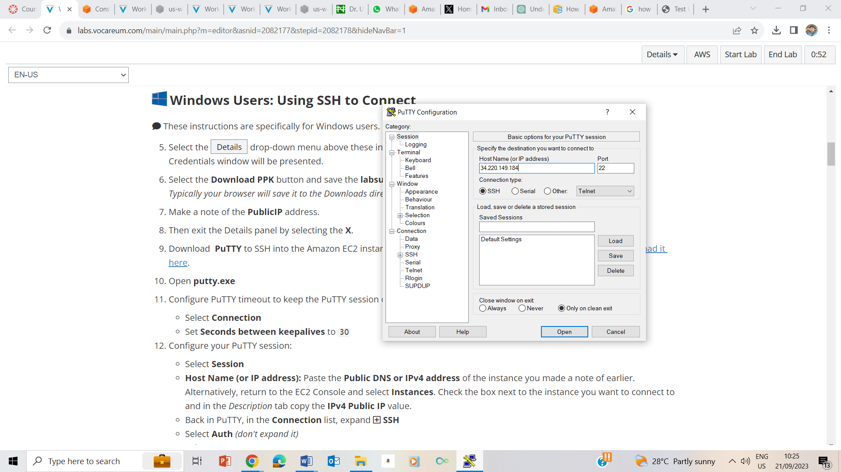

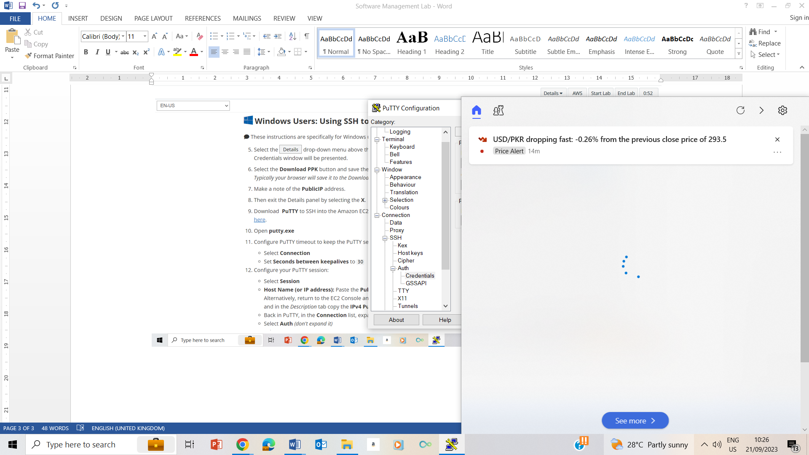

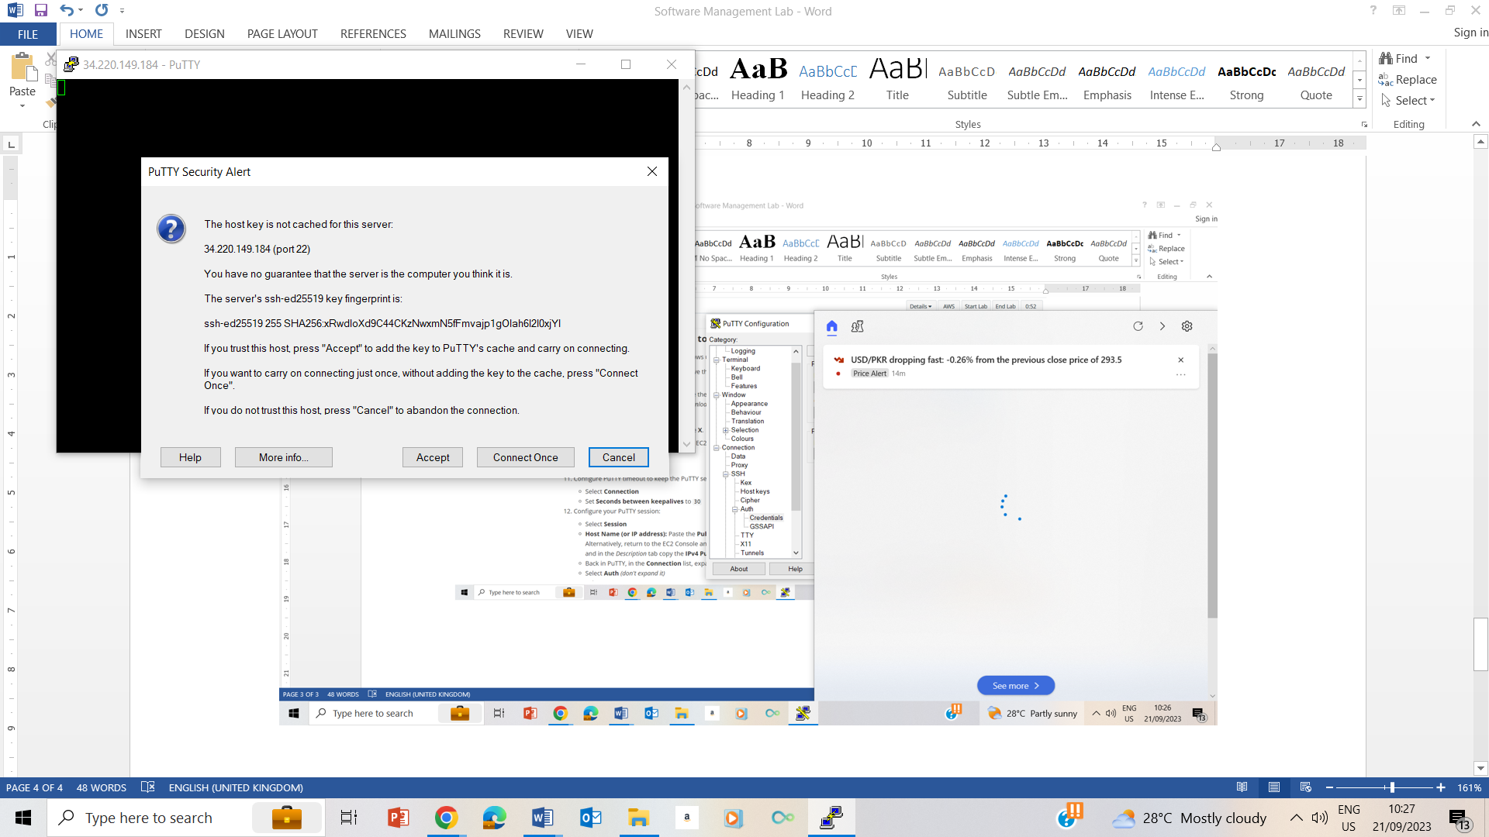

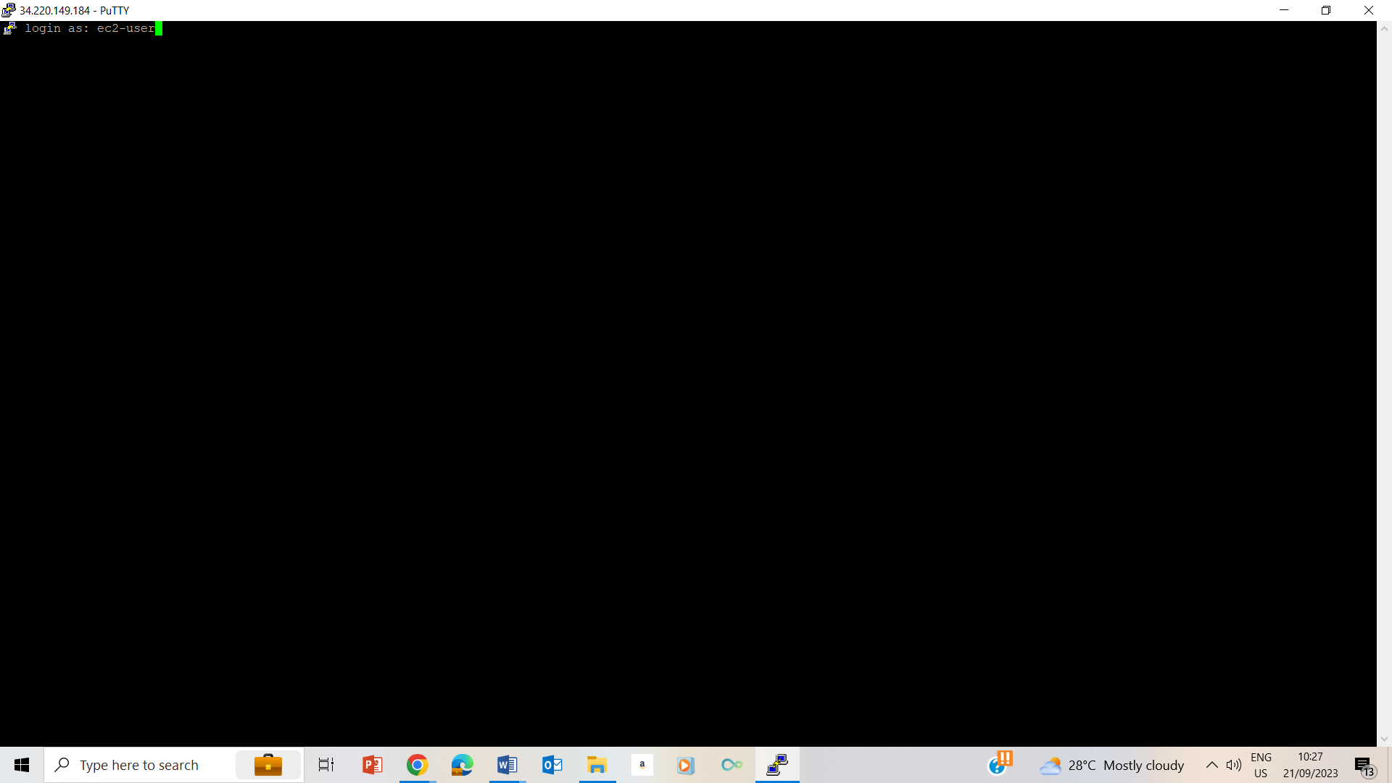

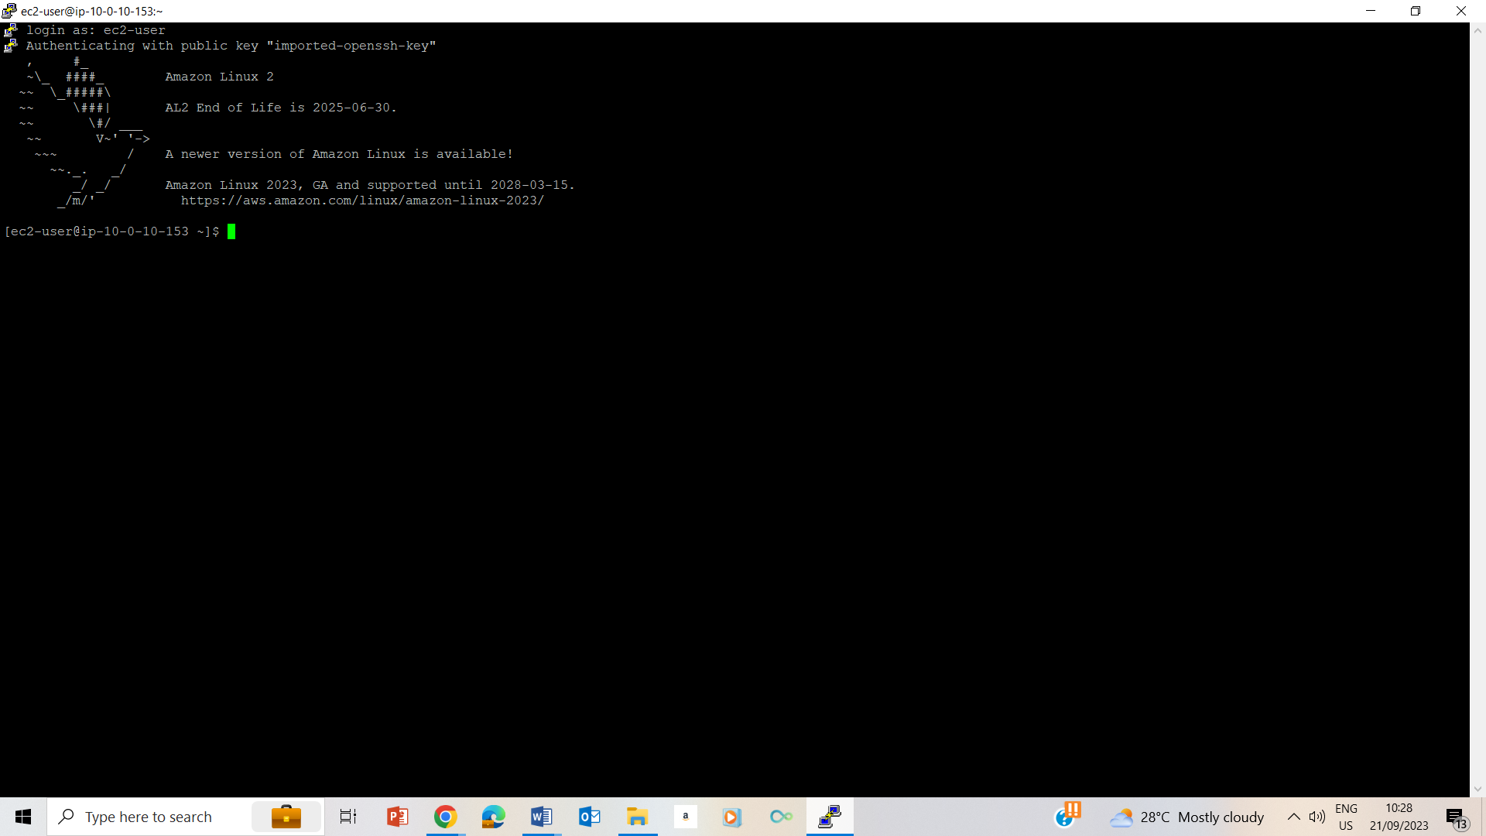

9-14

## Task 2: Update your Linux machine

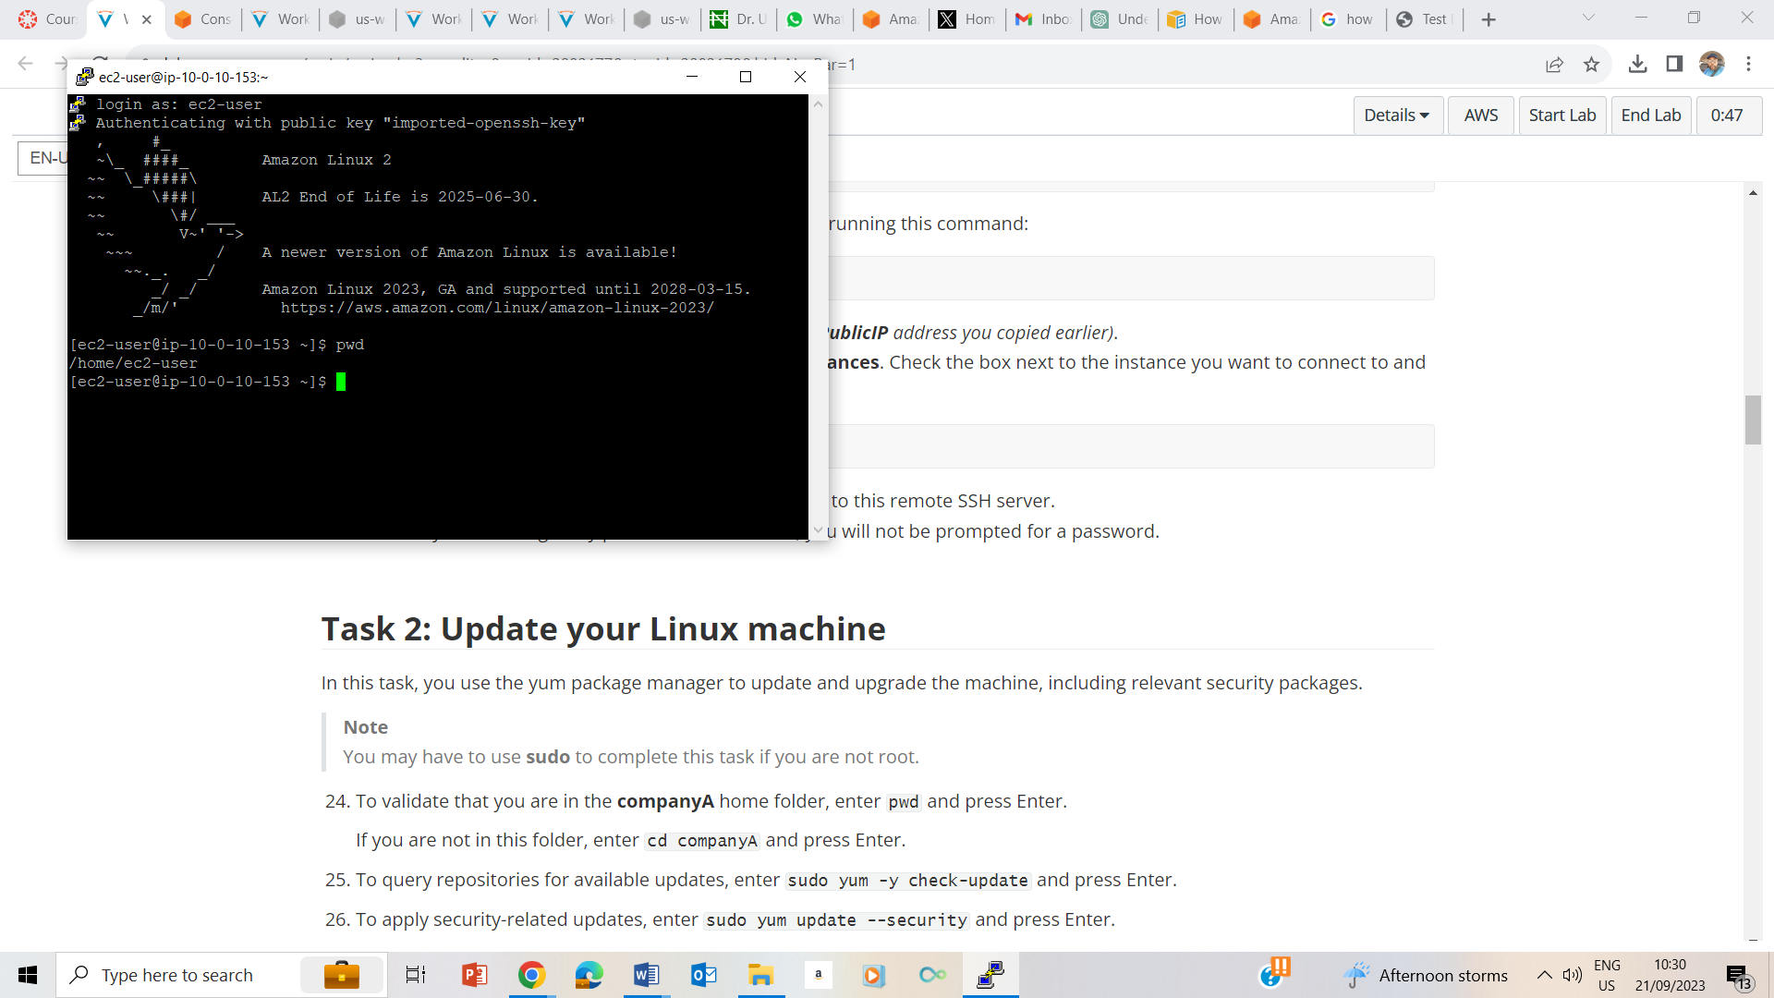

24. Confirmed I am on the /home/ec2-user folder by typing pwd and enter

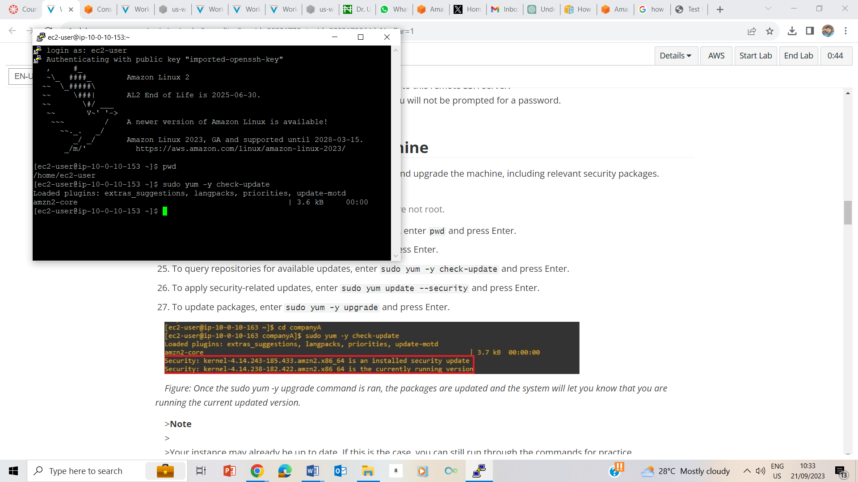

25. Checking for update

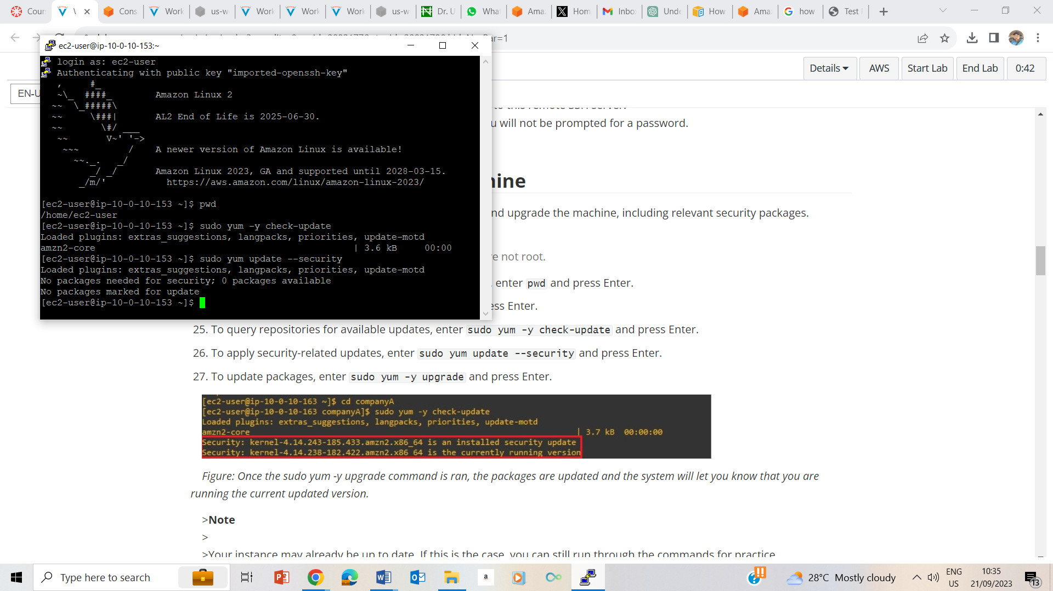

26. Applying security related updates

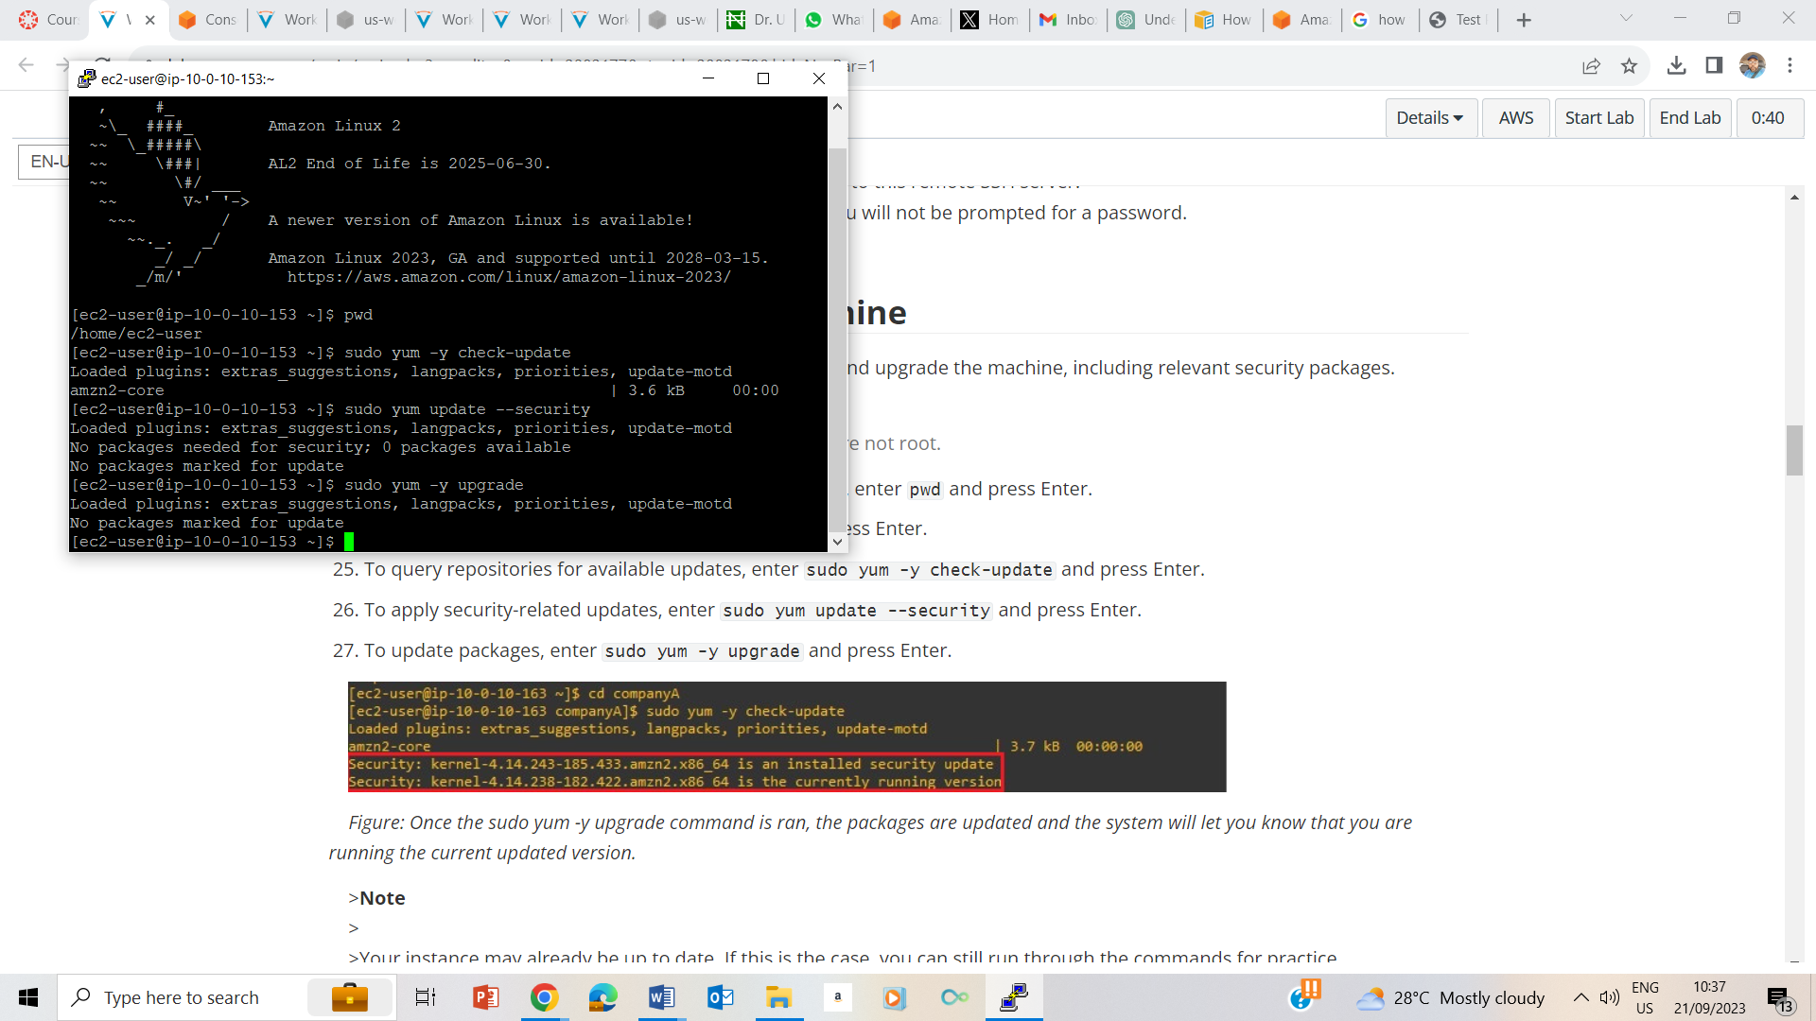

27. Update Packages

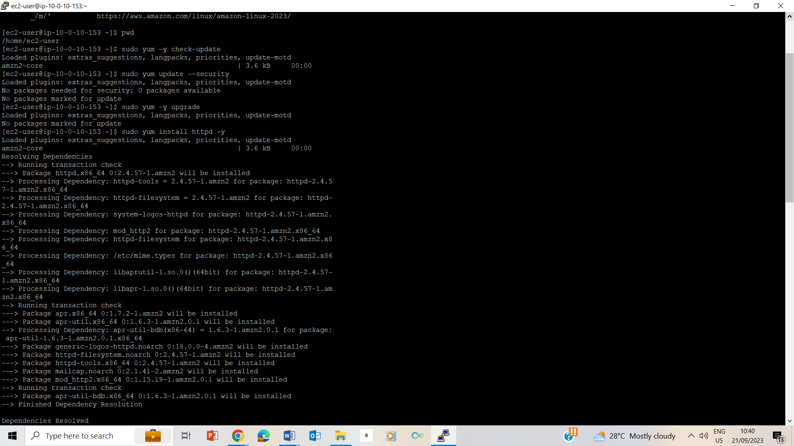

28. installing of packages

## Task 3: Roll back a package

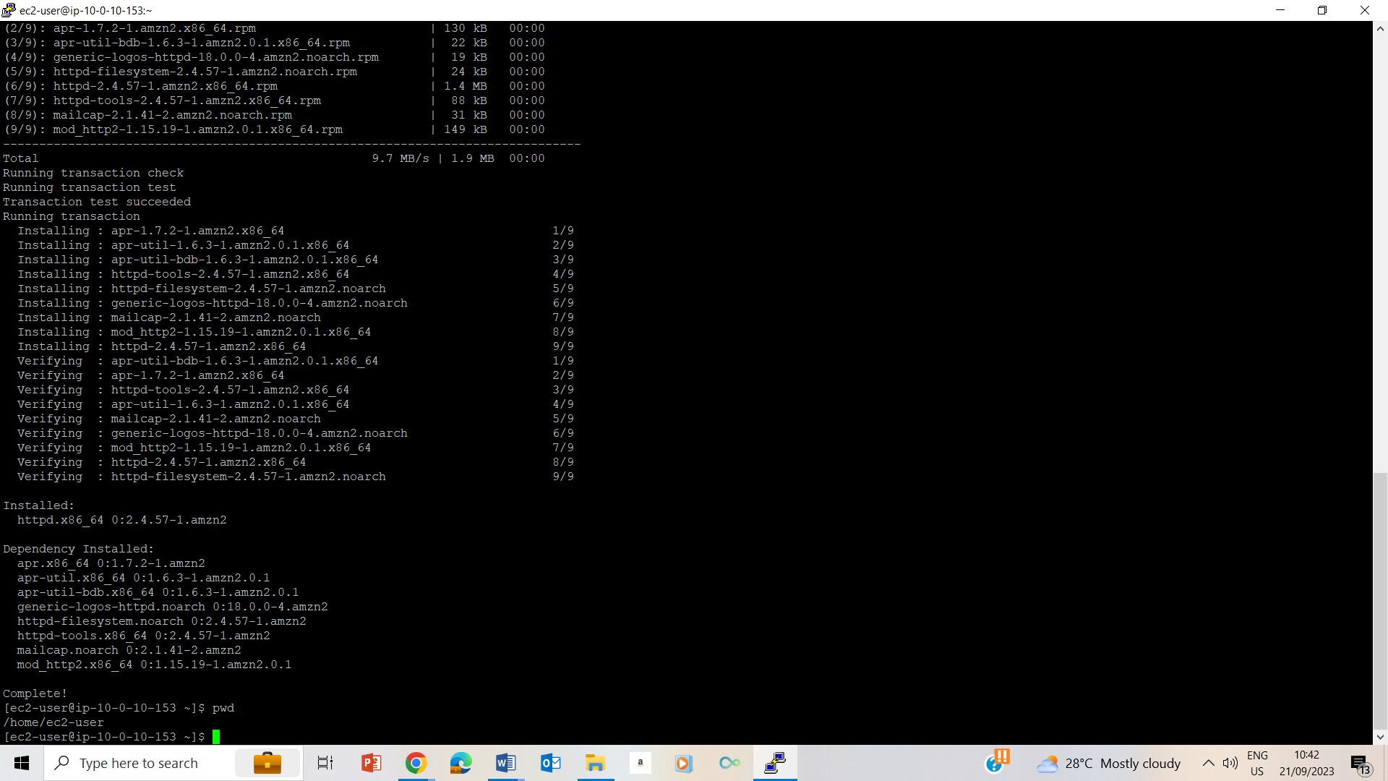

29. confirming I am on the /home/ec2-user by typing pwd and enter

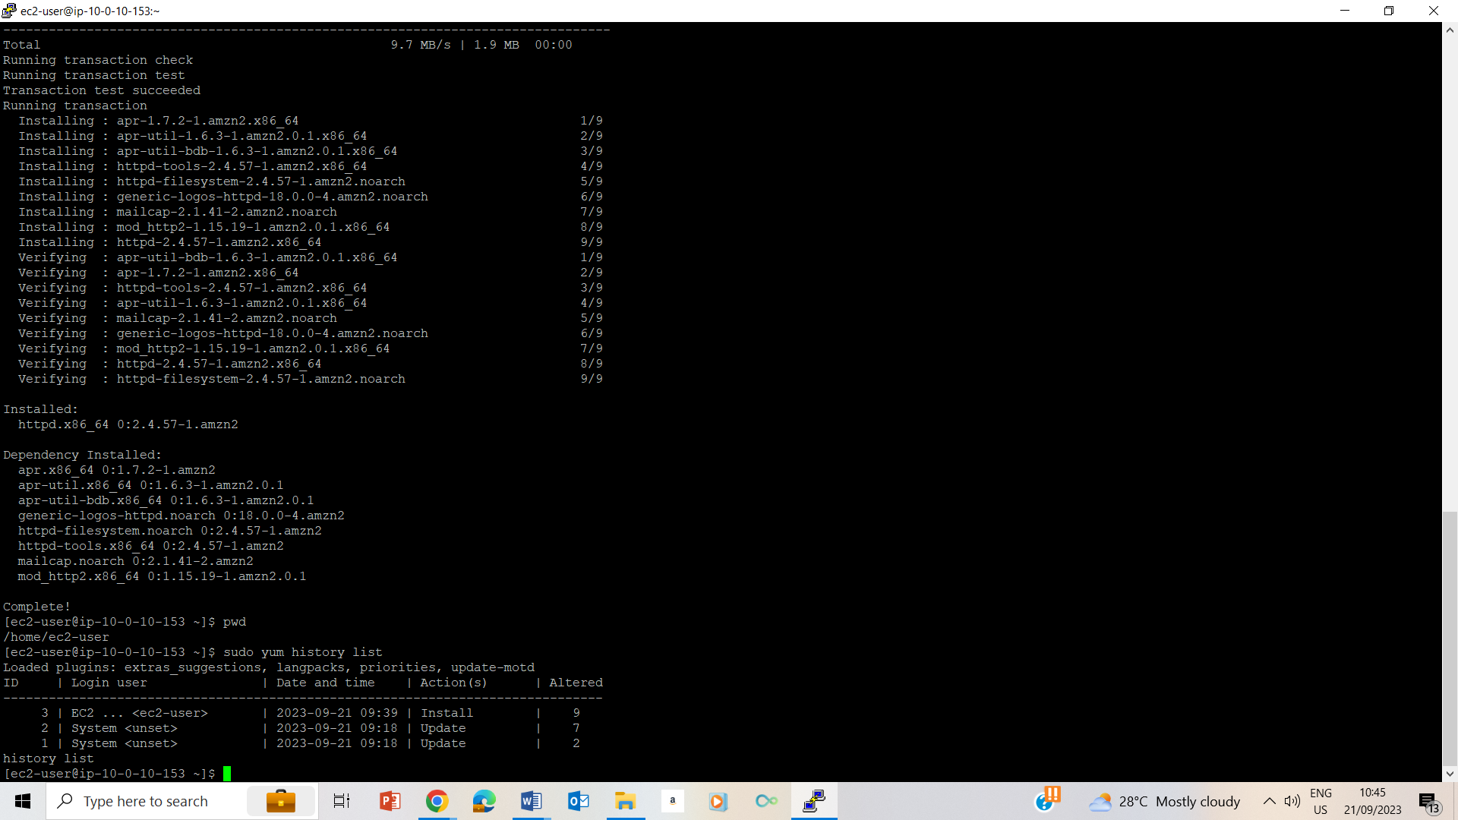

30. View history of updates. Ec2 id number is 3

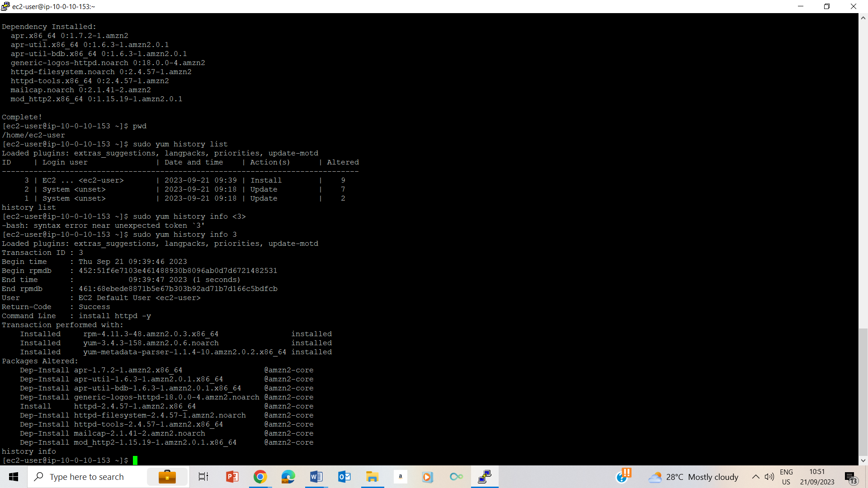

31. Viewing the most recent update sudo yum history info 3

## Task 4: Install the AWS CLI on Red Hat Linux